**DAILY ONLINE ACTIVITIES SUMMARY**

|  |  |  |  |  |  |  |  |
| --- | --- | --- | --- | --- | --- | --- | --- |
| **Date:** | **7/06/2020** | | | | **Name:** | **Imran Khan** | |
| **Sem & Sec** | **8th A** | | | | **USN:** | **4AL16CS040** | |
| **Online Test Summary** | | | | | | | |
| **Subject** | | **---** | | | | | |
| **Max. Marks** | | **--** | | **Score** | | **----** | |
| **Certification Course Summary** | | | | | | | |
| **Course** | **Modern java programming** | | | | | | |
| **Certificate Provider** | | | **udemy** | **Duration** | | | **3 HOURS** |
| **Coding Challenges** | | | | | | | |
| Problem Statement:  Write a C Program paring.. | | | | | | | |
| **Status: Solved** | | | | | | | |
| **Uploaded the report in Github** | | | | **yes** | | | |
| **If yes Repository name** | | | | **Imran040** | | | |
| **Uploaded the report in slack** | | | | **yes** | | | |

**Certification Course Details**:

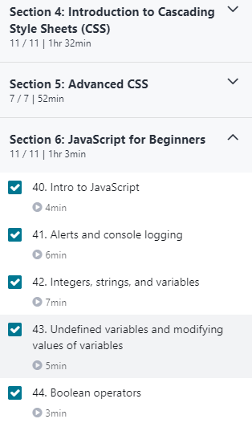

**Coding Challenges Details**:

**program1:**

|  |  |  |  |
| --- | --- | --- | --- |
|  | | | |
|  | |
| #include<stdio.h> | |
|  | | int main() |
|  | | { |
|  | | //fill the code |
|  | | int num1, num2; |
|  | | scanf("%d",&num1); |
|  | | scanf("%d",&num2); |
|  | | int sum1 = 0, sum2 = 0; |
|  | | for(int i = 1; i < num1; i++) |
|  | | { |
|  | | if(num1 % i == 0) |
|  | | { |
|  | | sum1 = sum1 + i; |
|  | | } |
|  | | } |
|  | | for(int i = 1; i < num2; i++) |
|  | | { |
|  | | if(num2 % i == 0) |
|  | | { |
|  | | sum2 = sum2 + i; |
|  | | } |
|  | | } |
|  | | if(sum1 == num1 && sum2 == num2) |
|  | | printf("Friendly Pair"); |
|  | | else |
|  | | printf("Not Friendly Pair"); |
|  | | return 0; |
|  | | } |